* Every browser has some default font for every generic font.

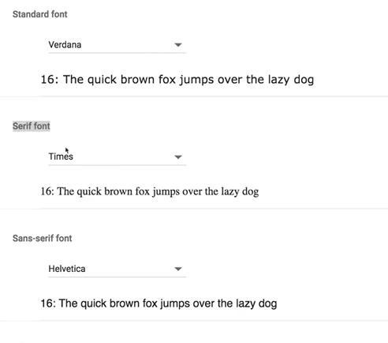

* If we don’t specify any font, browser will use the default font family.
* We can change it two ways:

1. Specify the generic family, in this case browser will use that generic family font.
2. Specify the font-family. In this case browser have no effect on font. Its better to get the font from CDN or from server.

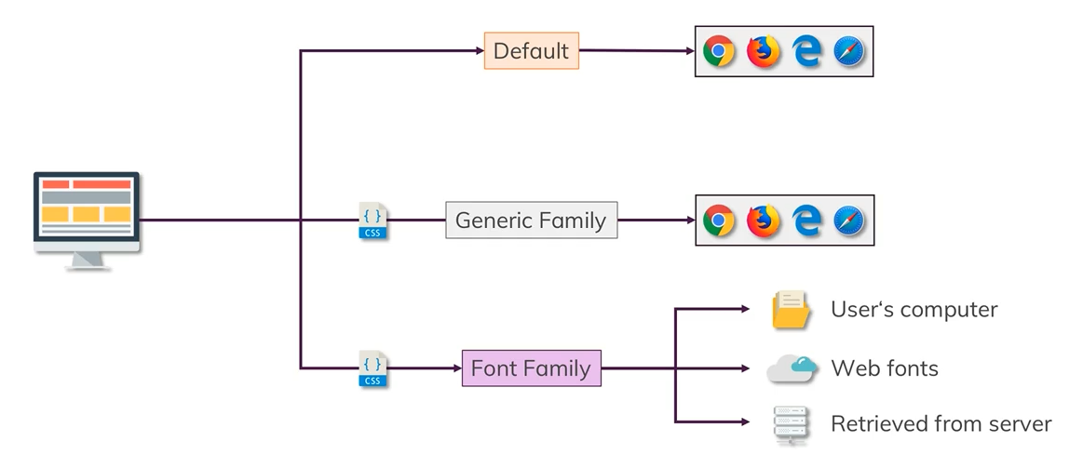

* Font family syntax: for fonts we can use google font page. We need to take care of font-faces if we want different size or bold italic etc



